**POSSIBLE QUESTIONS:**

Call with Distributors (who would stock)

E.g. Builders merchants, etc

Goal - find out what would be the criteria for stocking Cambond’s product

On the call

* Introduce ourselves, say we’re working on a student project with an inventor (Cambond) who are developing product that they (the retailers) might be interested in stocking - fire resistant boards. Would they be available to answer five questions?
* Potentially: can we record the conversation (anonymously?) so that we can later transcribe (and do nothing else)?

1. Which class (A/B/C…) and fire rating (minutes of resistance) would you be most interested in stocking? (We want to find out but can’t ask directly: What type of product they are interested in stocking? What are the classes they’re selling the most?)
2. What characteristics would a product need to have for them to be interested in stocking it if it doesn’t meet the A1/A2 class? Is it price? Or properties similar to plasterboard, concrete boards, plywood, wood composite, etc?
3. If the product doesn’t meet the ideal class (e.g it is of class C instead of B), would having significant improvement on the cost (e.g. is 40% cheaper), would that make the product attractive? How much cheaper would the product have to be?
4. If there is a new product they have never sold before, what factors would determine the quantity of the product they would order at first instance?
5. What’s the primary sustainability criteria they’d be interested in, if at all??

**To be asked to the manufacturers:**

Key ones: Saint-Gobain, Norbord (although it is wood, now acquired by West Fraser Timber), Promat

* Tests performed
* Fire retardant certificates and tests done by competition
* Certificates in general, e.g. this one by Norbord

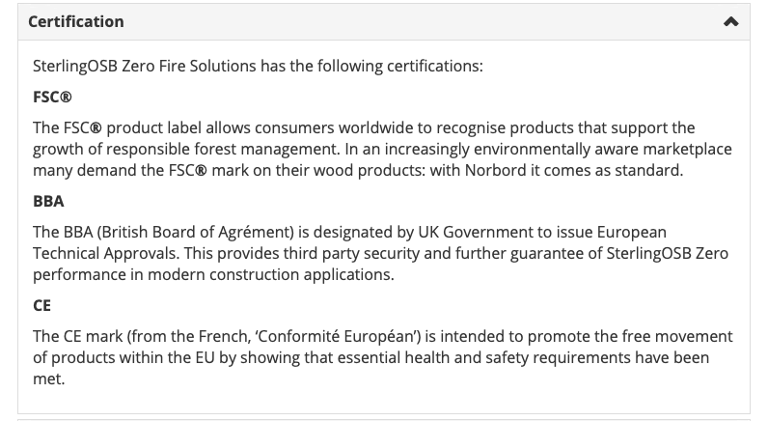

* Environmental pollution as a consequence of fire (remember case of formaldehyde for wood OSB)
* Dimensional change of panels as a consequence of panel moisture content, temperature, etc...
* Difficulties encountered by environmental/general groups. Which ones are attacking them? Why? How are they replying?
* **Which difficulties did they encounter? Any major incident?**
* To gypsum people: cons and pro of them, vs cement boards, wood boards
* To cement people: cons and pro of them, vs gypsum boards, wood boards
* To wood people: cons and pro of them, vs gypsum boards, cement boards
* **Bulk prices, how do they decide the bulking price?**

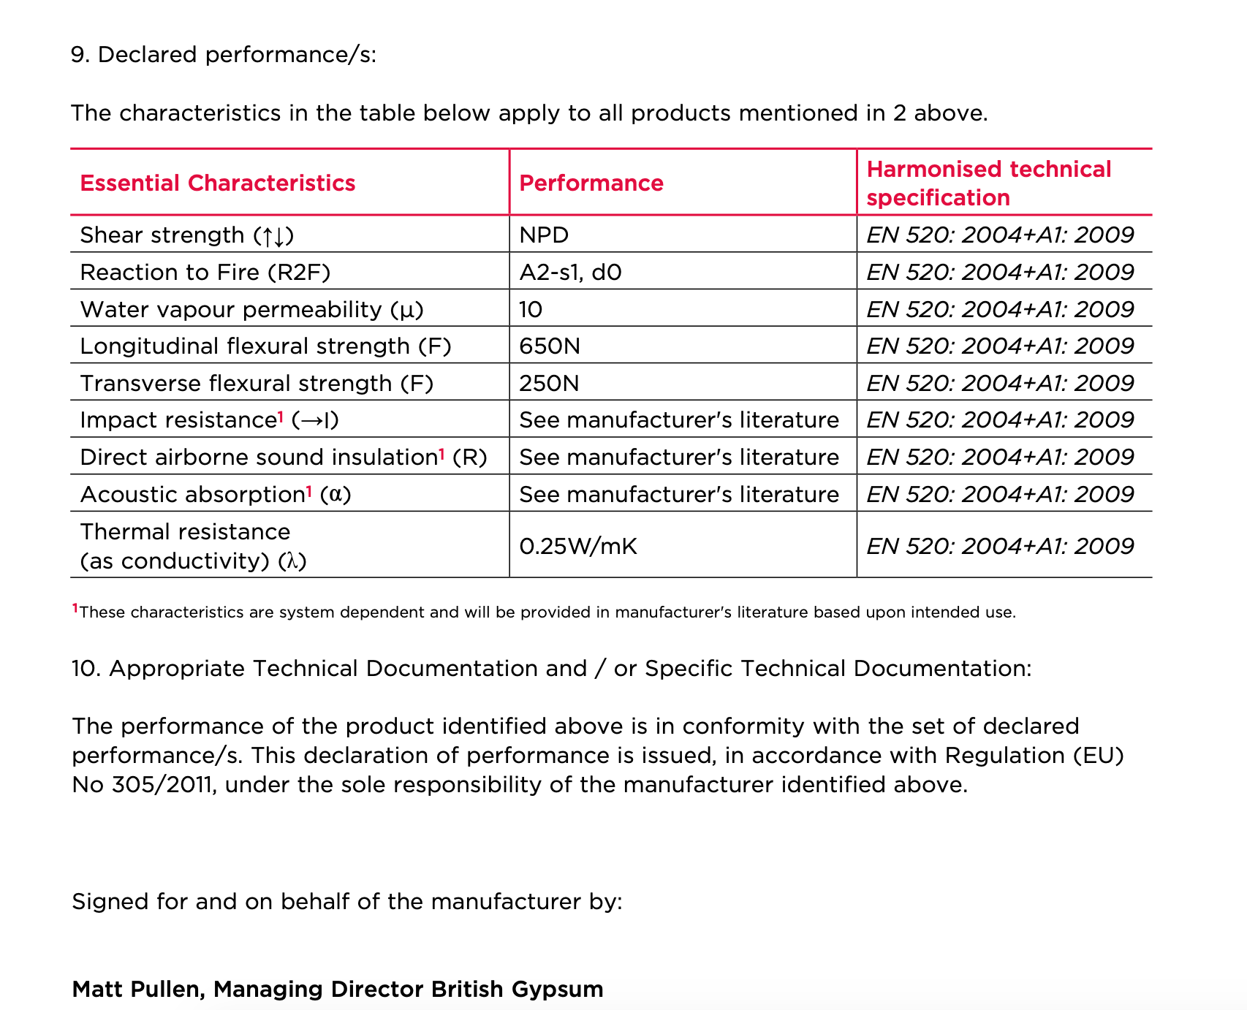

**To be asked to buyers:**

* What types of flat boards are you buying and why?
* Why are you buying this specific flat board?
* Which characteristics do you look for in flame-retardant flat boards?
* What are the three key things for you? (Highlight the flame-retardant aspect)
* Would you pay a premium for one of these properties?
  + Environmentally friendly?
  + Relatively lower toxicity?
* Are you aware of the gypsum-board flame retardant chemicals?
* Does your client, if any, care about which materials, or just the cost
* Is there a customer preference for gypsum/cement/wood-based boards?
* What process do you undertake to check the reliability of a board?
* Would you be willing to try a new one? Are there any barriers to get a new brand into your distribution process?
* What do you think of CAMBOND board?

**To be asked to the general public:**

* Demographics
  + Age
  + Income-level
  + Area of residence in UK
  + Already a home-owner or are you planning to buy one?
* Are the materials used for your house, buildings, in construction in general, important for you?
  + Yes
  + No
  + Maybe
* Which characteristics are you looking for in building materials? (We can ask them to rank what is most important)
  + Cost-effectiveness
  + Environmentally-friendly features
  + Safety
  + Reliability
  + Durability
  + Ease of procurement
  + Recommendation from builder
  + Recommendation from friends/family
  + Other factors
* In particular for flat boards?
  + Cost-effectiveness
  + Environmentally-friendly features
  + Safety
  + Reliability
  + Durability
  + Ease of procurement
  + Recommendation from builder
  + Recommendation from friends/family
  + Other factors
* Are you aware of flame-retardant flatboards?
  + Yes
  + No
* Are you aware of flame retardant chemicals used in this class of flatboards?
  + Yes
  + No
* These flame-retardant chemicals are often composed of chlorine and bromine which can be toxic when exposed to fires. Were you aware of this?
  + Yes, and I am highly concerned about this
  + Yes, and this does not matter to me
  + No, but I am highly concerned about this now
  + No, and this does not matter to me
* Our client is pitching a product which would be environmentally friendly and use inorganic materials such as fly ash to impart the flame retardant properties. Would such a product interest you?
  + Yes
  + No
  + Maybe
* Would you be willing to pay a premium price for this product, given its non-toxic and environmentally friendly nature?
  + Yes, up to 10% above the market price
  + Yes, up to 25% above the market price
  + Yes, up to 50% above the market price
  + Yes, up to 75% above the market price
  + Yes, up to 100% above the market price
  + No, I would not pay above market price

**To be asked to activists, researchers who are interested in flame retardant building materials/flat boards:**

* Which are the threats that you are trying to tackle?
* Which companies are moving in the right direction?
* Could you help us identify some niches? Who is willing to pay more for us? (so that we do not have to lower prices) What they want to see from us?